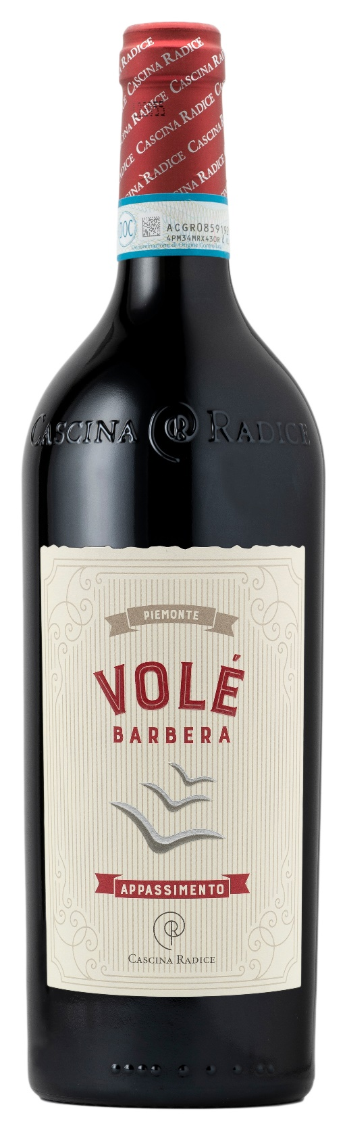
BARBERA PIEMONTE DOC APPASSIMENTO - VOLÉ

Grape: Barbera 100%
Alc. Vol.%: 14,5
Vintage: 2023
Residual sugar g/l: 9,0
Total acidity g/l: 6,0
Region: Piedmont
Production zone: Vineyards in the area of Agliano and Moasca (Province of Asti)
Capacity: 750ml

CHARACTERISTICS

Vinification: After late harvest, a traditional peel maceration is made for 14-18 days
Aging: short time in oak barrels followed by steel tanks for 6-8 months
Yield per ha: 12000kg
Colour: Deep red with purple reflections
Bouquet: Fruity and intense
Flavour: Smooth, balanced, full-bodied, with noble tannins

SERVING SUGGESTIONS

Best enjoyed with savoury first dishes, grilled meat and cold cuts.
Serving temperature 16-18 °C
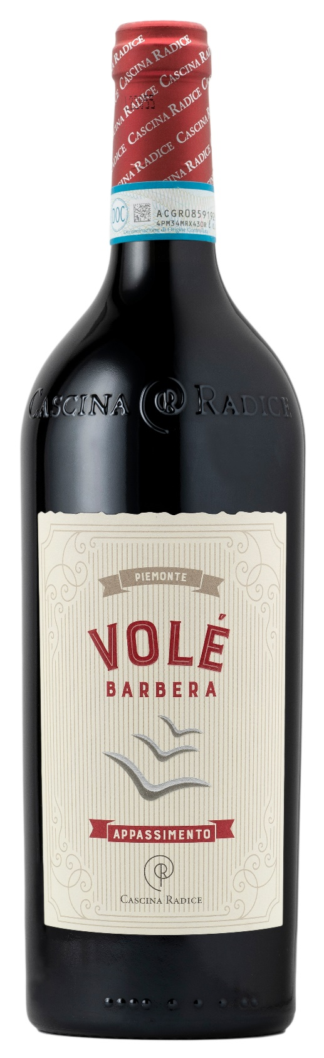
TECHNICAL INFORMATION / PALLETIZING

Size 750ml:
Article Nr. V02010A
GTIN-13 bottle 8017868001140
GTIN-13 carton 8017868001157
Closure Cork
Bottles / carton 6 bottles
Pallet size 80x120cm
Cartons/layer 19
Cartons/pallet 95
Kg/carton 9,95
Kg/pallet 965

Contains sulphites
GMO Free
Revisione 01. 20.12.2023

